**Test cases:**

1. **Email message:**

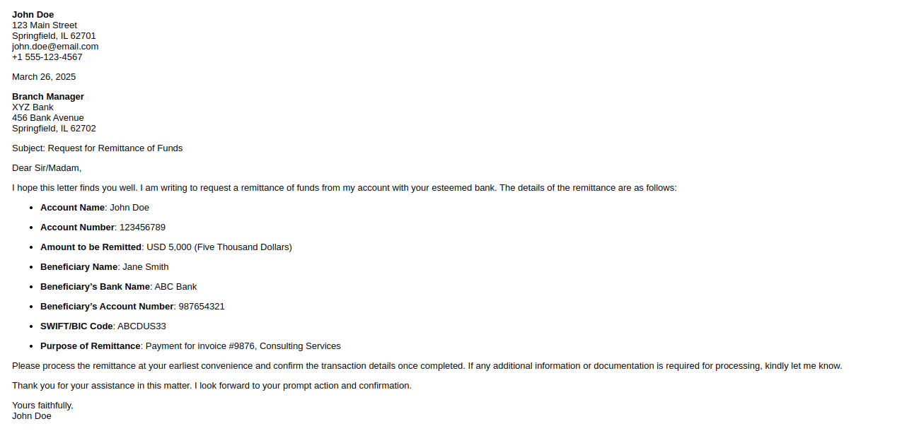

**Result:**

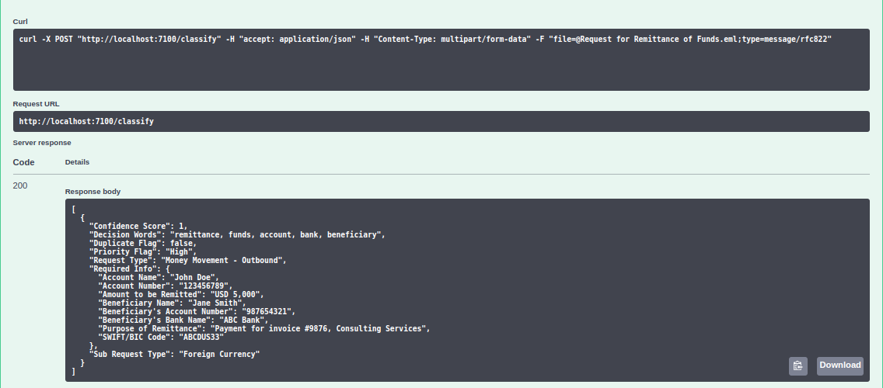

**Result after resubmission (Duplicate):**

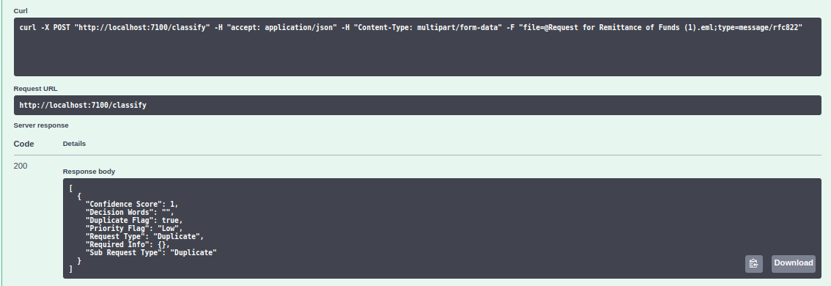

1. **Docx file:**

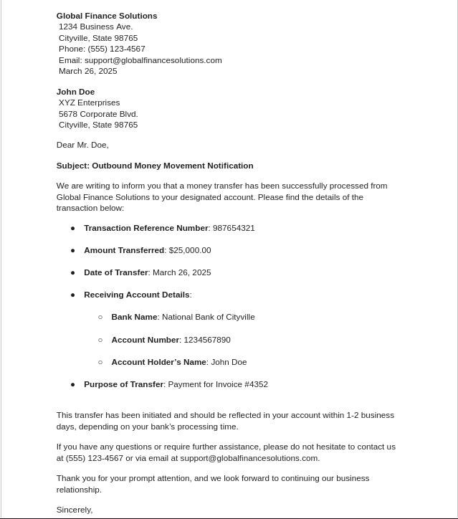

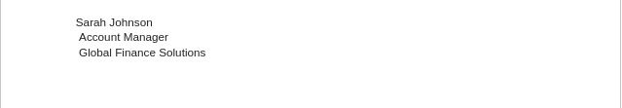

**Result:**

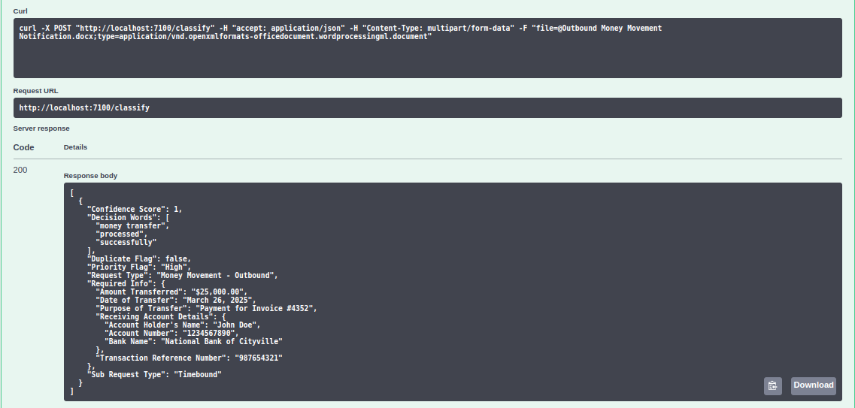

1. **PDF file:**

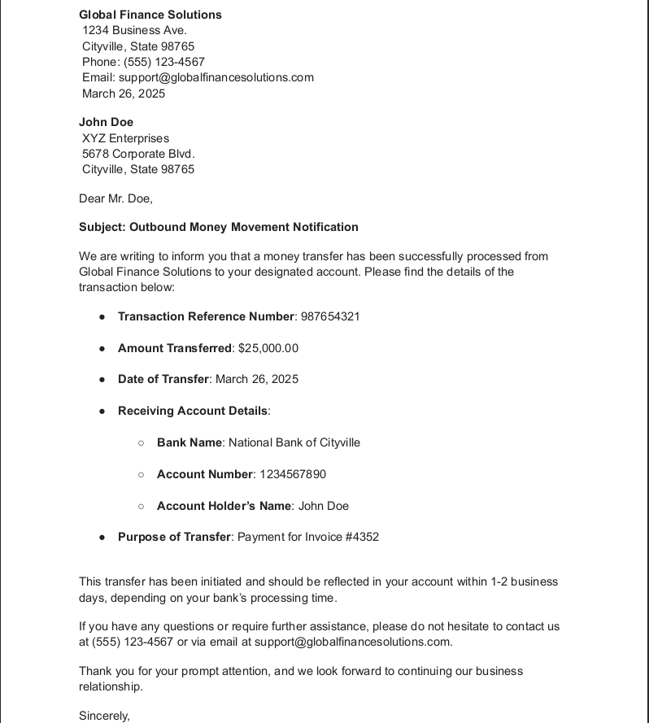

**Result:**

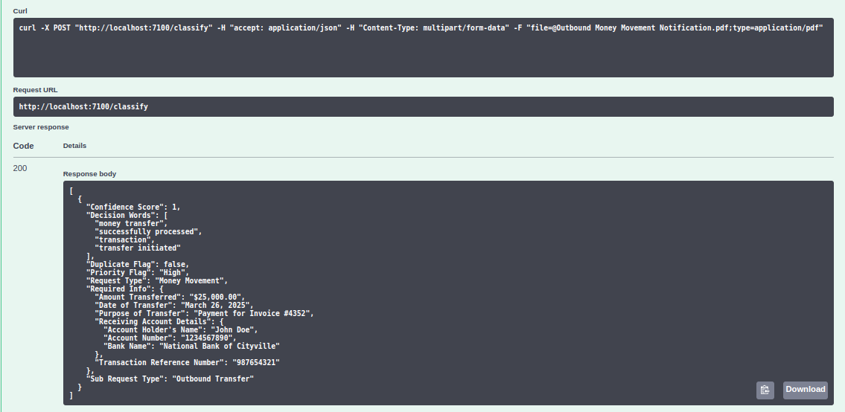

1. **Bulk upload:**

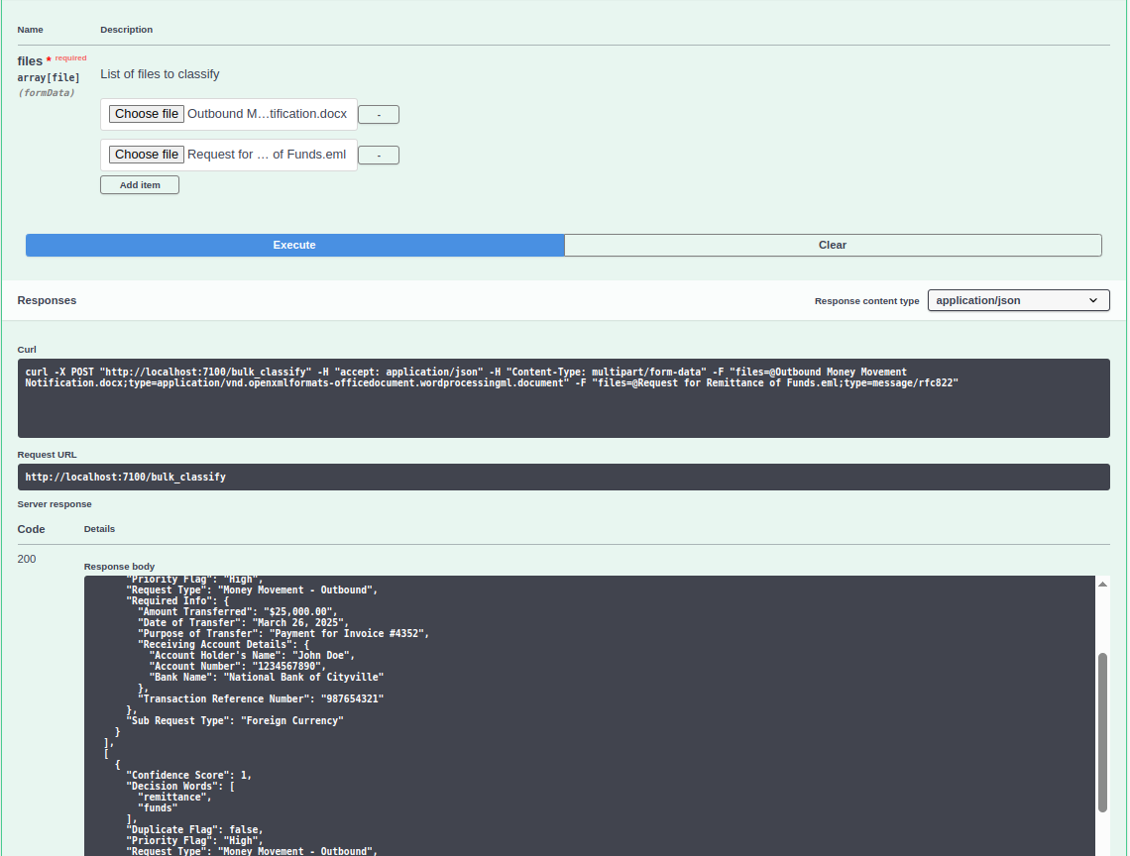

**Result:**

**[**

**[**

**{**

**"Confidence Score": 1,**

**"Decision Words": [**

**"money transfer",**

**"processed",**

**"successfully"**

**],**

**"Duplicate Flag": false,**

**"Priority Flag": "High",**

**"Request Type": "Money Movement - Outbound",**

**"Required Info": {**

**"Amount Transferred": "$25,000.00",**

**"Date of Transfer": "March 26, 2025",**

**"Purpose of Transfer": "Payment for Invoice #4352",**

**"Receiving Account Details": {**

**"Account Holder's Name": "John Doe",**

**"Account Number": "1234567890",**

**"Bank Name": "National Bank of Cityville"**

**},**

**"Transaction Reference Number": "987654321"**

**},**

**"Sub Request Type": "Foreign Currency"**

**}**

**],**

**[**

**{**

**"Confidence Score": 1,**

**"Decision Words": [**

**"remittance",**

**"funds"**

**],**

**"Duplicate Flag": false,**

**"Priority Flag": "High",**

**"Request Type": "Money Movement - Outbound",**

**"Required Info": {**

**"Account Name": "John Doe",**

**"Account Number": "123456789",**

**"Amount to be Remitted": "USD 5,000",**

**"Beneficiary Name": "Jane Smith",**

**"Beneficiary's Account Number": "987654321",**

**"Beneficiary's Bank Name": "ABC Bank",**

**"Purpose of Remittance": "Payment for invoice #9876, Consulting Services",**

**"SWIFT/BIC Code": "ABCDUS33"**

**},**

**"Sub Request Type": "Foreign Currency"**

**}**

**]**

**]**

1. **Update configuration:**

